Containerization and DevOps Lab

EXPERIMENT – 01



Name – Siddharth Negi

Batch - B3

Sap_id - 500121910

Roll_no - R2142231376

Objective
- To understand the conceptual and practical differences between Virtual Machines and Containers.
- To install and configure a Virtual Machine using VirtualBox and Vagrant on Windows.
- To install and configure Containers using Docker inside WSL.
- To deploy an Ubuntu-based Nginx web server in both environments.
- To compare resource utilization, performance, and operational characteristics of VMs and Containers.

Theory
Virtual Machine (VM)
A Virtual Machine emulates a complete physical computer, including its own operating system kernel, hardware drivers, and user space. Each VM runs on top of a hypervisor.
Characteristics:
- Full OS per VM
- Higher resource usage
- Strong isolation
- Slower startup time

Container
Containers virtualize at the operating system level. They share the host OS kernel while isolating applications and dependencies in user space.
Characteristics:
- Shared kernel
- Lightweight
- Fast startup
- Efficient resource usage

Experiment Setup – Part A: Virtual Machine (Windows)
Step 1: Install VirtualBox
- Download VirtualBox from the official website.
- Run the installer and keep default options.
- Restart the system if prompted.
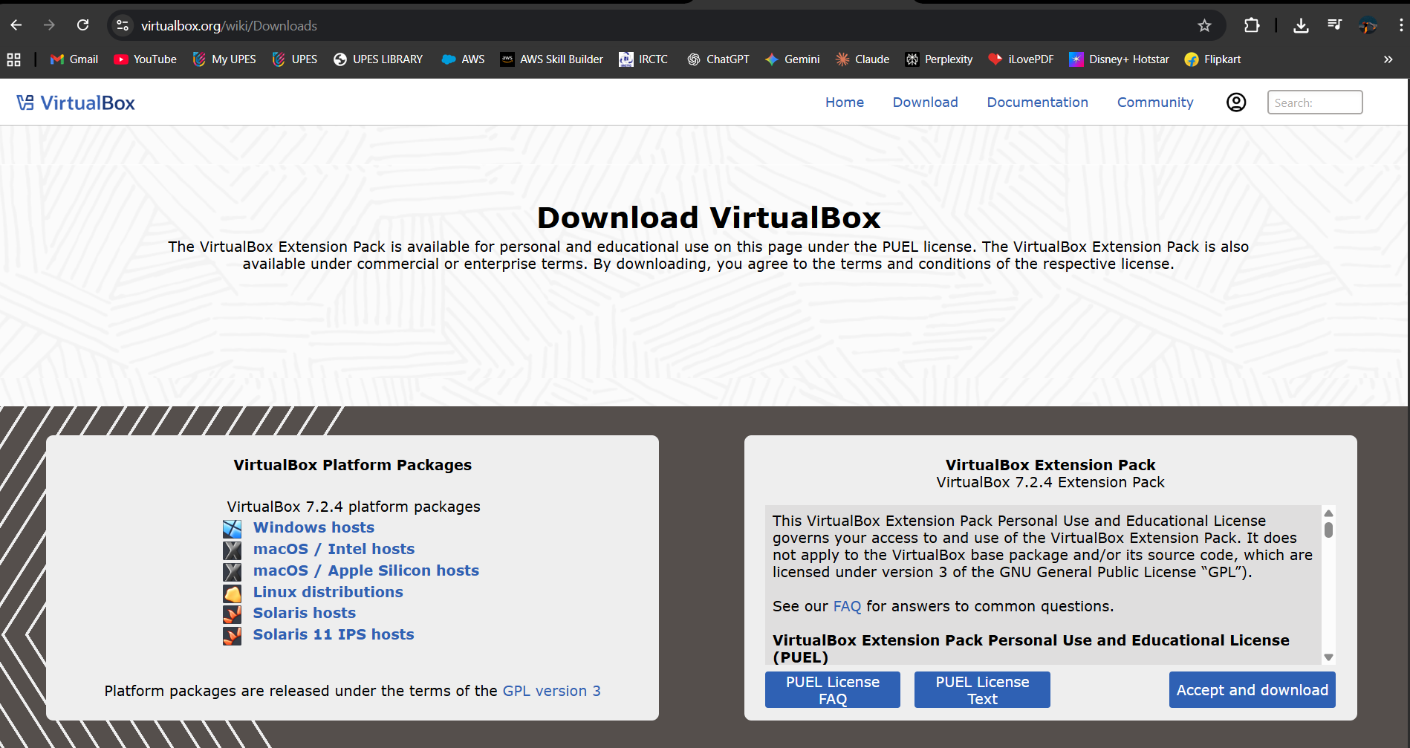

Step 2: Install Vagrant
- Download Vagrant for Windows.
- Install using default settings.
- Verify installation:
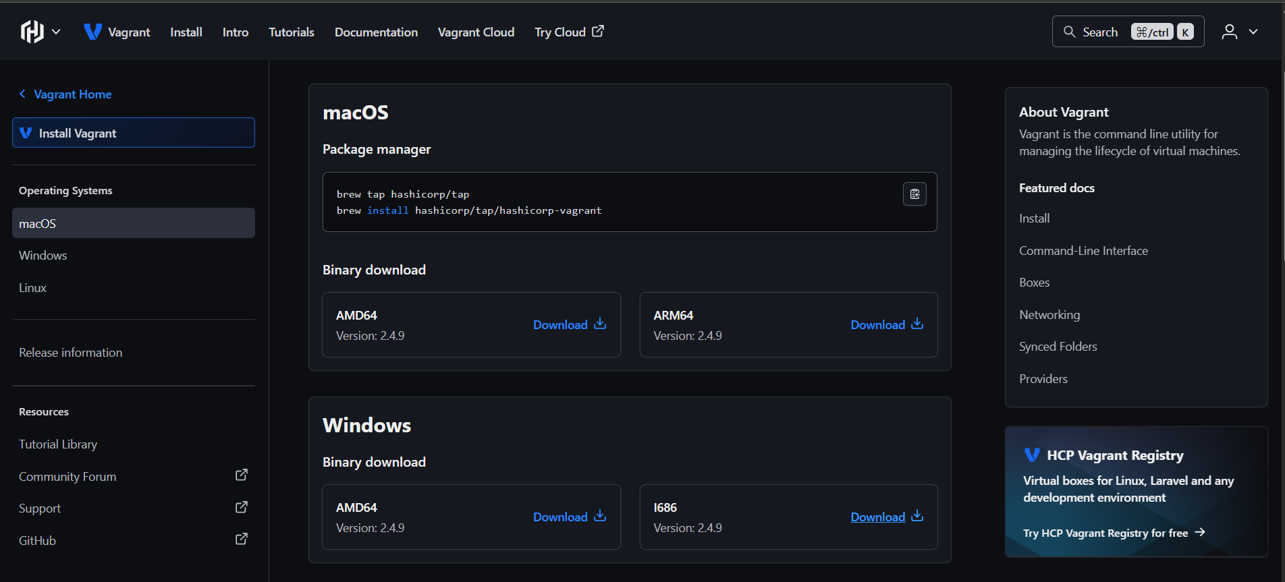
Code : vagrant --version
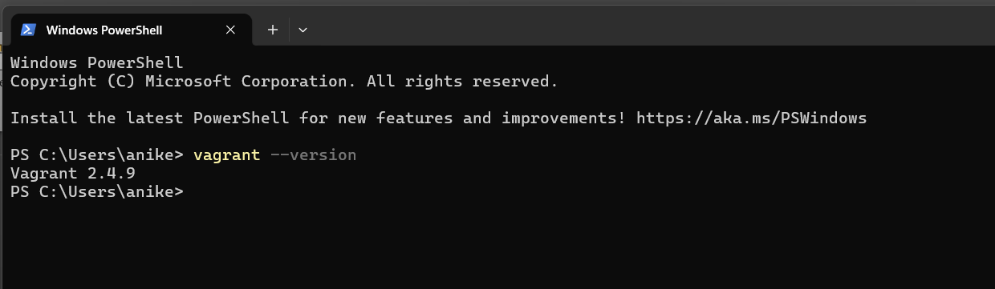

Step 3: Create Ubuntu VM using Vagrant
- Initialize Vagrant with Ubuntu box:
Code: vagrant init hashicorp/bionic64
- Start the VM
Code: vagrant up
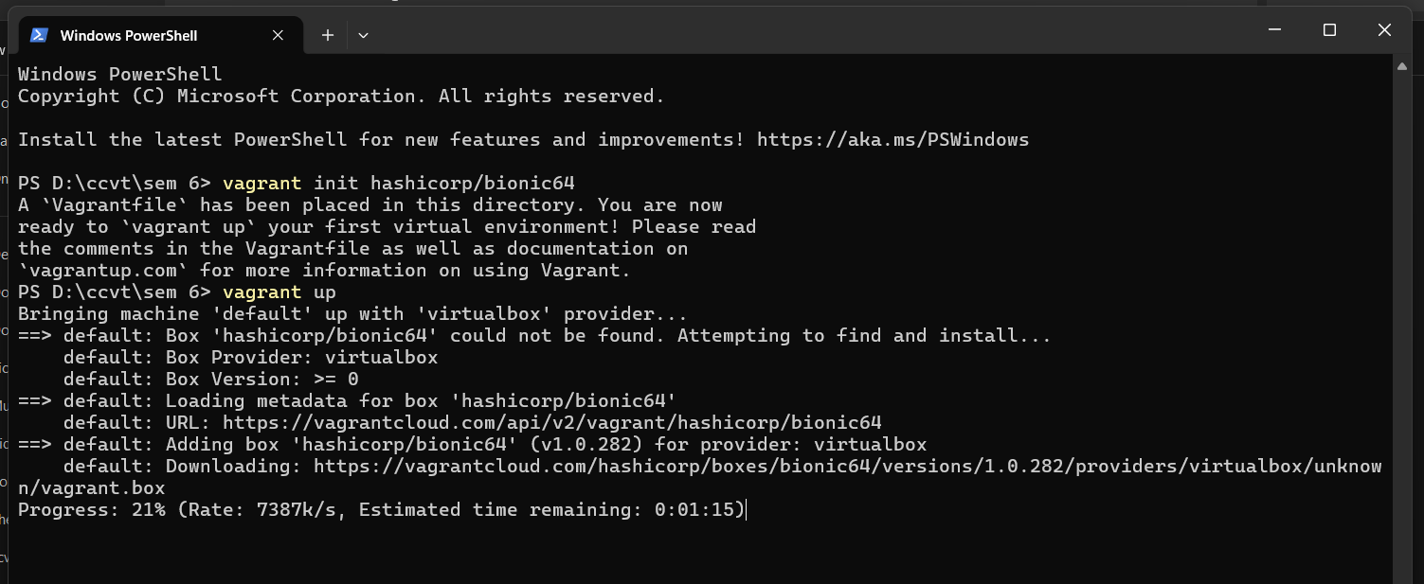
When you run vagrant init hashicorp/bionic64, Vagrant creates a configuration file called Vagrantfile inside the project folder. This file contains all the instructions needed to create a virtual machine. In hashicorp/bionic64, HashiCorp is the publisher of the Vagrant box, bionic refers to Ubuntu 18.04 LTS (Bionic Beaver), and 64 indicates that it is a 64-bit operating system.
When you run vagrant up, Vagrant reads the Vagrantfile and communicates with VirtualBox (or another configured provider). If the required Ubuntu image is not already available on the system, Vagrant automatically downloads the box. It then creates a virtual machine, allocates system resources such as CPU, RAM, and network settings, and finally boots the Ubuntu virtual machine, making it ready for use.
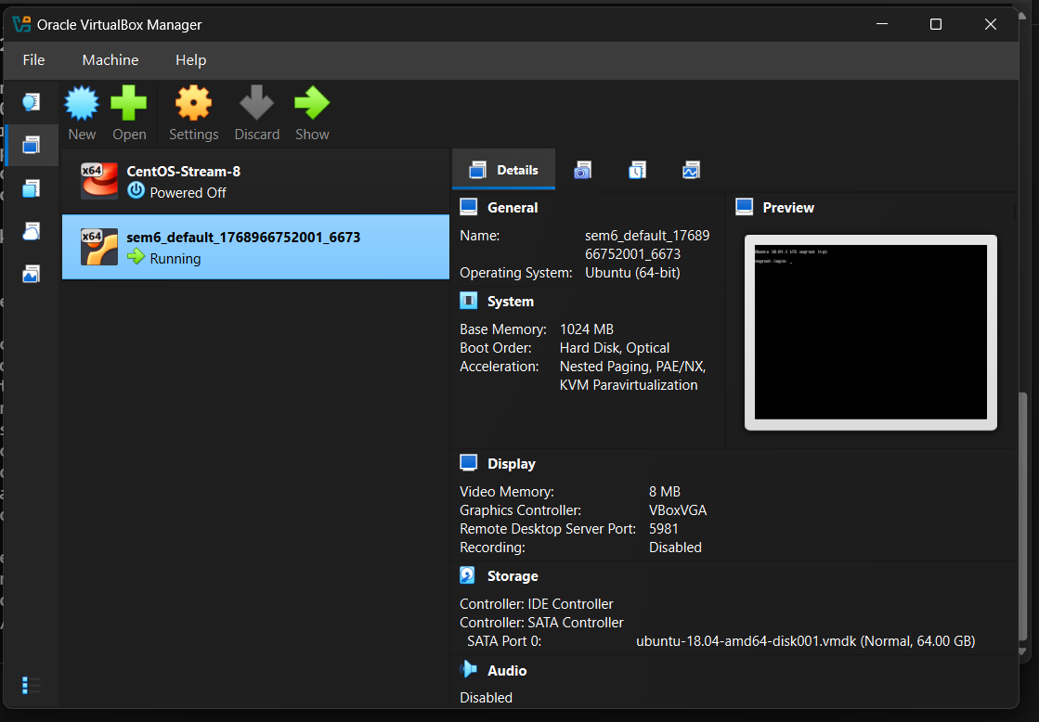
- Access the VM:
Code: vagrant ssh
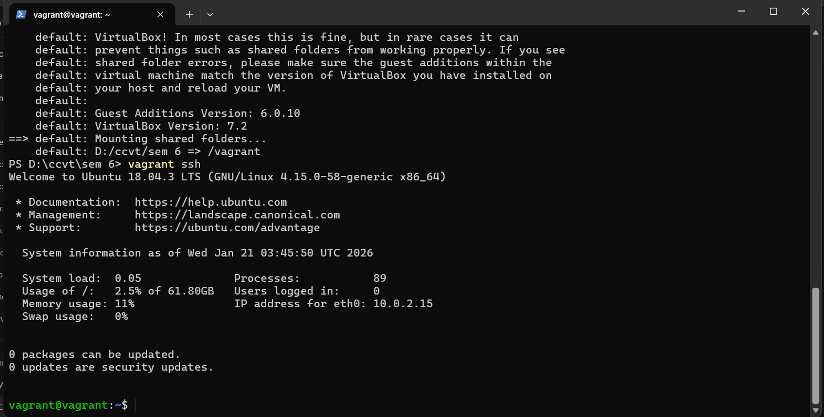

What’s happening?
- Vagrant connects you to the VM using SSH
- You enter the Ubuntu terminal without password
- You are now inside the virtual machine

Step 4: Install Nginx inside VM
Code:
- sudo apt update
- sudo apt install -y nginx
- sudo systemctl start nginx
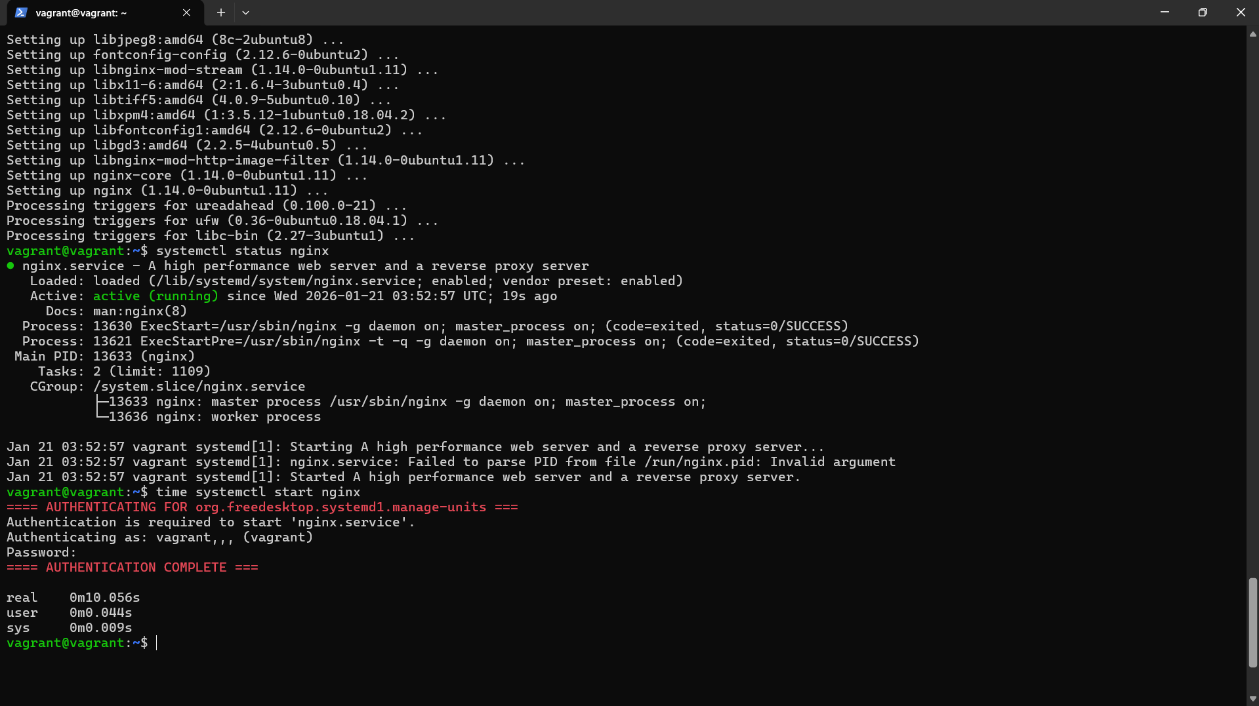
Code: time systemctl start nginx
What this command does (combined explanation)
systemctl start nginx
- This command tells systemd (Linux service manager) to start the Nginx web server service on the system.
- The time keyword measures how long the command takes to execute.
Starts the Nginx service and measures the time taken to start it.
Step 5: Verify Nginx
Code: curl localhost
Stop and remove vm
Code:
- vagrant halt
- vagrant destroy
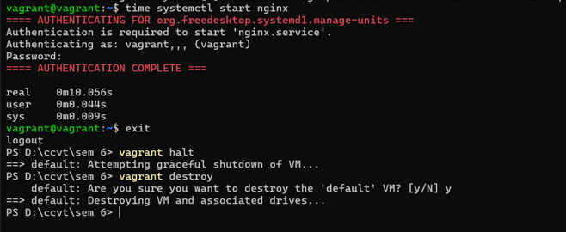

Experiment Setup – Part B: Containers using WSL (Windows)
Step 1: Install WSL 2
Code: wsl --install
Verify installation
Code: wsl --version
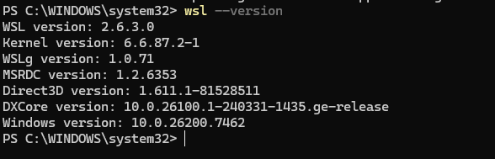
Step 2: Install Ubuntu on WSL
Code: wsl --install -d Ubuntu
Verify installation
Code: wsl -l -v
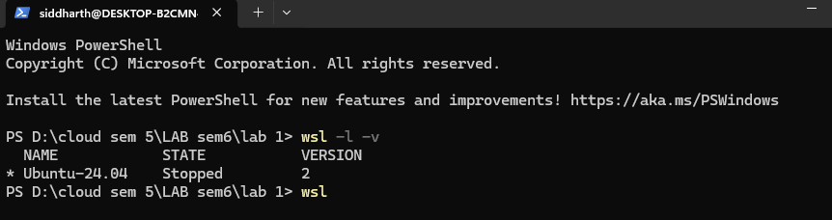
Step 3: Install Docker Engine inside WSL
Code:
- sudo apt update
- sudo apt install -y docker.io
- sudo systemctl start docker
- sudo usermod -aG docker $USER
- verify installation
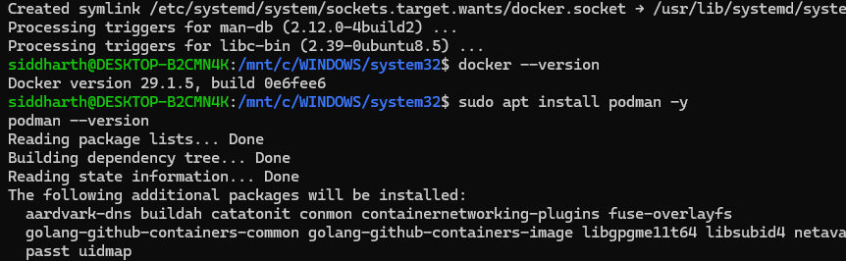

Step 4: Run Ubuntu Container with Nginx
Code: docker pull ubuntu
docker run -d -p 8080:80 --name nginx-container nginx
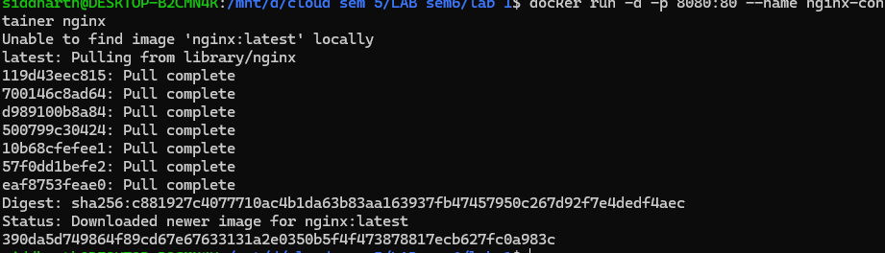

Docker pull ubuntu: This command downloads the Ubuntu Linux image from Docker Hub to your system.
Docker run -d -p 8080:80 –name nginx-container nginx: It creates and runs an Nginx container in the background and maps it to port 8080 on your system.

Step 5: Verify Nginx in Container
Code: curl localhost:8080
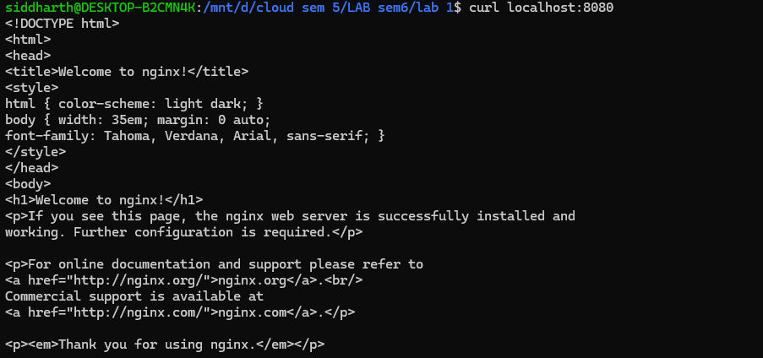

Resource Utilization Observation
VM Observation Commands
Code: free -h
What it does:
- Displays memory (RAM) usage of the system
What it shows:
Total RAM Used RAM Free RAM Available RAM Swap memory


Code: htop
What it does:
- Shows real-time system performance
What it displays:
CPU usage RAM usage Running processes Process IDs, users, load average
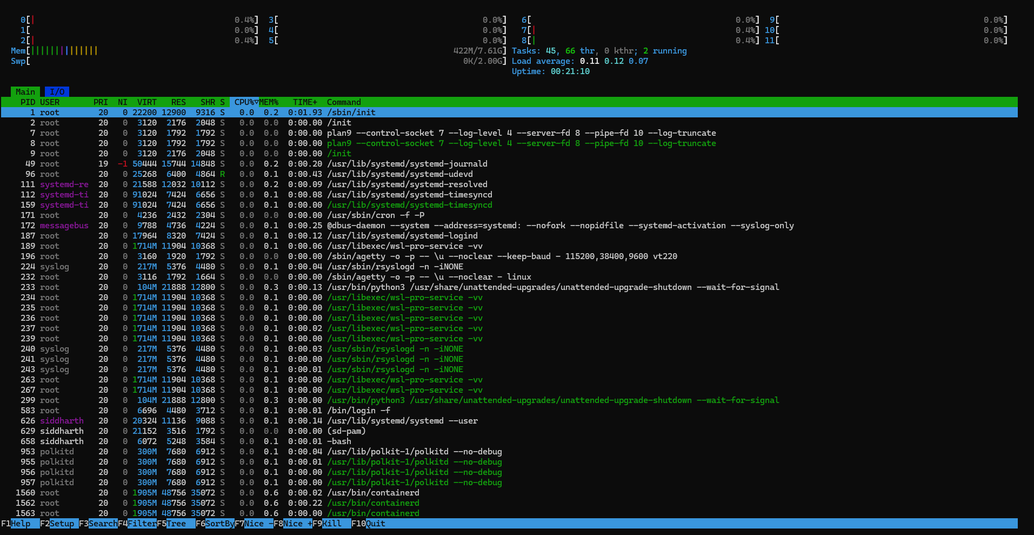

Code: systemd-analyze
What it does:
- Measures system boot time
What it shows:
- Time taken by:
  - Kernel
  - Userspace
- Total boot time

Container Observation Commands
Code: docker stats

What it does:
- Shows real-time resource usage of running containers
What you’ll see:
CPU usage Memory usage / limit Network I/O Disk I/O
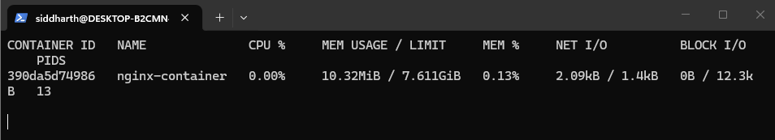

Code: free -h
What this command does
- Displays the system’s memory (RAM) usage
- Shows how much memory is:
  - Total Used Free Available Swap
The -h flag means human-readable (MB / GB instead of bytes).
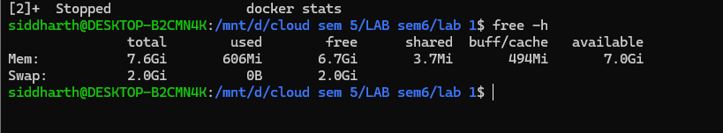

Parameters to Compare: Virtual Machine vs Container
Parameter | Virtual Machine | Container
Boot Time | High | Very Low
RAM Usage | High | Low
CPU Overhead | Higher | Minimal
Disk Usage | Larger | Smaller
Isolation | Strong | Moderate

Explanation of Each Parameter
Boot Time
- Virtual Machine: Takes more time to start because it boots a full operating system.
- Container: Starts almost instantly since it shares the host OS kernel.

RAM Usage
- Virtual Machine: Requires dedicated memory for its own OS and services.
- Container: Uses less memory as it shares system resources with the host.

CPU Overhead
- Virtual Machine: More CPU usage due to hardware virtualization.
- Container: Minimal overhead because applications run directly on the host kernel.

Disk Usage
- Virtual Machine: Needs large disk space for OS image and virtual disks.
- Container: Lightweight images consume less storage.

Isolation
- Virtual Machine: Strong isolation as each VM runs its own OS.
- Container: Moderate isolation since containers share the host OS kernel.

Conclusion
Virtual Machines are suitable for full OS isolation and legacy workloads, whereas Containers are ideal for microservices, rapid deployment, and efficient resource utilization.

